

ML ASSIGNMENT - 3
Sales Forecasting using Linear Regression
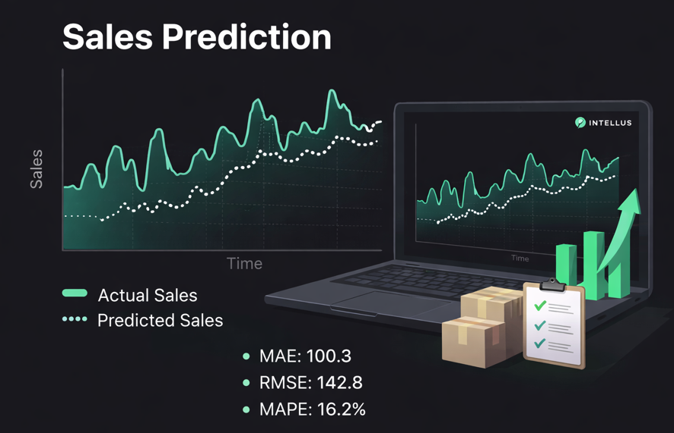
Complete Assignment Guide

1. Objective
Use Linear Regression to forecast daily sales by converting time series data into supervised learning format using feature engineering.

2. Understanding the Approach
Sales forecasting is a time series problem. We convert it into a regression problem by creating time-based and lag features so that Linear Regression can learn patterns.

3. Feature Engineering Steps
Create:
• Year, Month, Day
• Day of Week
• Week of Year
• Is Weekend
• Lag_1
• Lag_7
• Rolling Mean (7-day average)
These features help capture trend and seasonality.
1. Year, Month, Day
These features extract date components from the date column.
They help models understand seasonal and yearly patterns.
Syntax
df['Year'] = df['date'].dt.year
df['Month'] = df['date'].dt.month
df['Day'] = df['date'].dt.day
Example
Date | Year | Month | Day
2024-01-15 | 2024 | 1 | 15
Use Case
- Detect yearly trends
- Detect monthly seasonality

2. Day of Week
This feature represents which day of the week the date belongs to.
Encoding
Value | Day
0 | Monday
1 | Tuesday
2 | Wednesday
3 | Thursday
4 | Friday
5 | Saturday
6 | Sunday
Syntax
df['Day_of_Week'] = df['date'].dt.dayofweek
Example
Date | Day_of_Week
2024-01-15 | 1
Use Case
- Identify weekday vs weekend patterns
- Retail sales forecasting

3. Week of Year
This feature tells which week number of the year a date belongs to.
Syntax
df['Week_of_Year'] = df['date'].dt.isocalendar().week
Example
Date | Week_of_Year
2024-01-15 | 3
Use Case
- Weekly seasonality
- Demand forecasting

4. Is Weekend
This feature indicates whether the day is weekend or weekday.
Encoding
Value | Meaning
0 | Weekday
1 | Weekend
Syntax
df['Is_Weekend'] = df['date'].dt.dayofweek.apply(lambda x: 1 if x >= 5 else 0)
Example
Date | Is_Weekend
2024-01-13 | 1
2024-01-15 | 0
Use Case
- Retail traffic prediction
- Restaurant demand prediction

5. Lag Feature (Lag_1)
Lag features represent previous values of the target variable.
Lag_1 means value from previous day/time step.
Syntax
df['Lag_1'] = df['sales'].shift(1)

Example
Date | Sales | Lag_1
Jan1 | 100 | NaN
Jan2 | 120 | 100
Jan3 | 140 | 120
Use Case
- Time series forecasting
- Detect temporal dependency

6. Lag Feature (Lag_7)
Lag_7 represents value from 7 days earlier.
Syntax
df['Lag_7'] = df['sales'].shift(7)
Example
Date | Sales | Lag_7
Jan8 | 200 | 100
Use Case
- Capture weekly patterns
- Seasonal trends

7. Rolling Mean (7-Day Moving Average)
Rolling mean calculates the average of the last 7 observations.
It helps smooth random fluctuations in time series data.
Formula
Rolling Mean=x1+x2+x3+...+x77Rolling\ Mean = \frac{x_1 + x_2 + x_3 + ... + x_7}{7}Rolling Mean=7x1 +x2 +x3 +...+x7
Syntax
df['Rolling_Mean_7'] = df['sales'].rolling(window=7).mean()
Example
Date | Sales | Rolling_Mean_7
Day7 | 140 | 120
Day8 | 150 | 130
Use Case
- Remove noise
- Identify trend patterns

4. What is Lag?
Lag means using past values of sales to predict future sales.
Examples:
Lag_1 → Yesterday's sales
Lag_7 → Sales from 7 days ago
Lag_30 → Sales from 30 days ago
Mathematically:
If Yt is today's sales, then Lag_1 = Y(t-1)
Why Lag is Needed?
• Sales data has memory.
• Today's sales depend on yesterday's sales.
• Weekly patterns repeat.
Without lag, the model has no memory.
With lag, the model learns trend and seasonality.
Important Rule:
Always create lag using shift() to avoid data leakage.
Example:
df['lag_1'] = df['sales'].shift(1)

5. What is Rolling Mean?
Rolling Mean (also called Moving Average) is the average of the previous n values in a time series.
It is used to smooth fluctuations and capture trend patterns in sales data.
Why Rolling Mean is Needed?
Rolling mean is needed as Sales data usually contains:
- Random Noise
Small unpredictable variations in daily sales that do not follow any specific pattern. These may occur due to minor operational changes, customer behavior, or measurement inconsistencies.
- Sudden Spikes Due to Promotions
Temporary increases in sales caused by discounts, special offers, marketing campaigns, or limited-time deals. These spikes are usually short-term but can significantly distort raw sales trends.

- Holiday Effects
Sales often increase or decrease during holidays and festive seasons. For example, retail sales may rise during festivals, while some businesses may experience lower demand on public holidays.

- Daily Fluctuations
Normal day-to-day variation in sales due to weekday vs weekend differences, weather changes, customer footfall, and seasonal demand patterns.
Because of these factors, raw sales data appears noisy and irregular.
Rolling Mean helps smooth these fluctuations and allows the model to capture the underlying trend more effectively.

How Rolling Mean Helps in Sales Forecasting?
Rolling Mean plays an important role in improving model performance. It helps in the following ways:
- Reduce Noise
Sales data often contains random fluctuations. Rolling mean smooths sudden ups and downs by averaging recent values.

- Capture Short-Term Trend
It highlights the recent direction of sales (increasing or decreasing), making trend patterns more visible.

- Make Predictions More Stable
By smoothing irregular spikes and drops, predictions become less volatile and more consistent.

- Help Linear Regression Learn Smoother Patterns
Linear Regression performs better when data follows a clear trend. Rolling mean reduces randomness, allowing the model to detect meaningful relationships more effectively.

Mathematical Formula
If:
Yₜ = Sales at time t
Then 7-day Rolling Mean is:
RM₇ = (Yₜ₋₁ + Yₜ₋₂ + Yₜ₋₃ + Yₜ₋₄ + Yₜ₋₅ + Yₜ₋₆ + Yₜ₋₇) / 7
Important:
We use only past values (t-1, t-2, etc.), never current or future values.

Example
Suppose daily sales are:
Day 1 → 100
Day 2 → 120
Day 3 → 130
Day 4 → 150
3-day Rolling Mean for Day 4:
(100 + 120 + 130) / 3 = 116.67
For Day 5:
(120 + 130 + 150) / 3 = 133.33
The average keeps “rolling” forward.

How to Create Rolling Mean in Python?
Correct Method (Avoid Data Leakage):

df['rolling_mean_7'] = df['sales'].shift(1).rolling(7).mean()
Explanation:
• shift(1) ensures we use only past data
• rolling(7) calculates average of last 7 days
• mean() computes the average

Never use:

df['sales'].rolling(7).mean()
This includes current day sales and causes data leakage.
Always use shift(1) before rolling.

6. Step-by-Step Implementation
Step 1: Load dataset.
Step 2: Convert date column to datetime.
Step 3: Create time-based features.
Step 4: Create lag features using shift().
Step 5: Drop missing values caused by lag.
Step 6: Perform time-based train-test split (no shuffling).
Step 7: Train Linear Regression model.
Step 8: Evaluate using MAE, RMSE, MAPE.
Step 9: Plot Actual vs Predicted sales.

7. Mathematical Model
Sales = C + M1X1 + M2X2 + ... + MnXn
Where X includes lag and time-based features.
The model minimizes Sum of Squared Errors (SSE).

8. Evaluation Metrics
• MAE → Average absolute error
• RMSE → Penalizes large errors
• MAPE → Percentage error (important for forecasting)

9. Bonus Improvements
• Add Lag_14 and Lag_30
• Add Rolling Standard Deviation
• Try Ridge/Lasso Regression

10. Final Submission Checklist
• Jupyter Notebook included
• Lag features clearly implemented
• Forecast graph included
• Evaluation metrics printed
• Business insights written

